[](https://scribehow.com/)Update Student ID in CB

1 Navigate to <https://apstudents.collegeboard.org/>

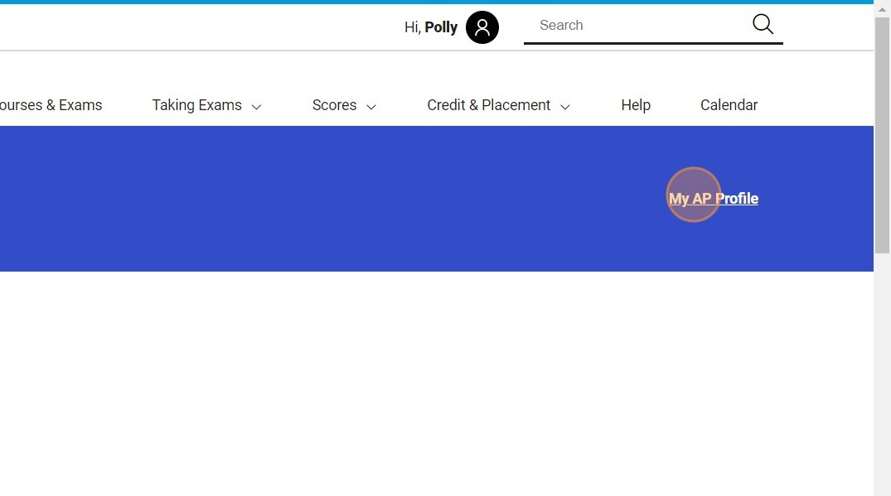

2 Click My AP Profile

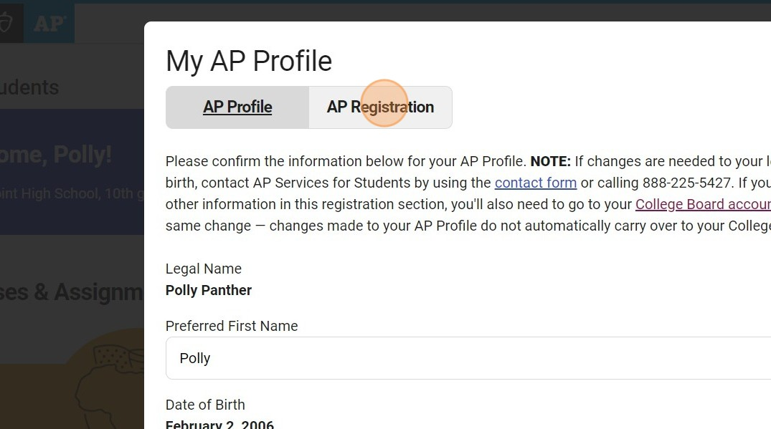

3 Click AP Registration

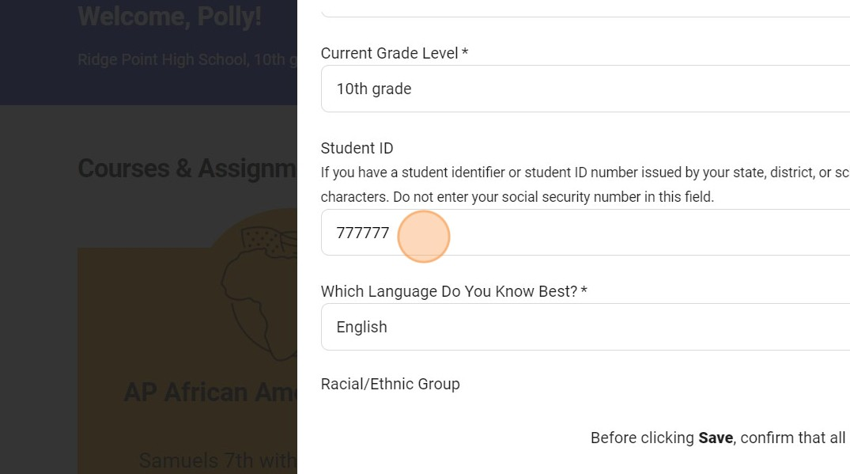

4 Scroll to your Student ID and enter your correct ID

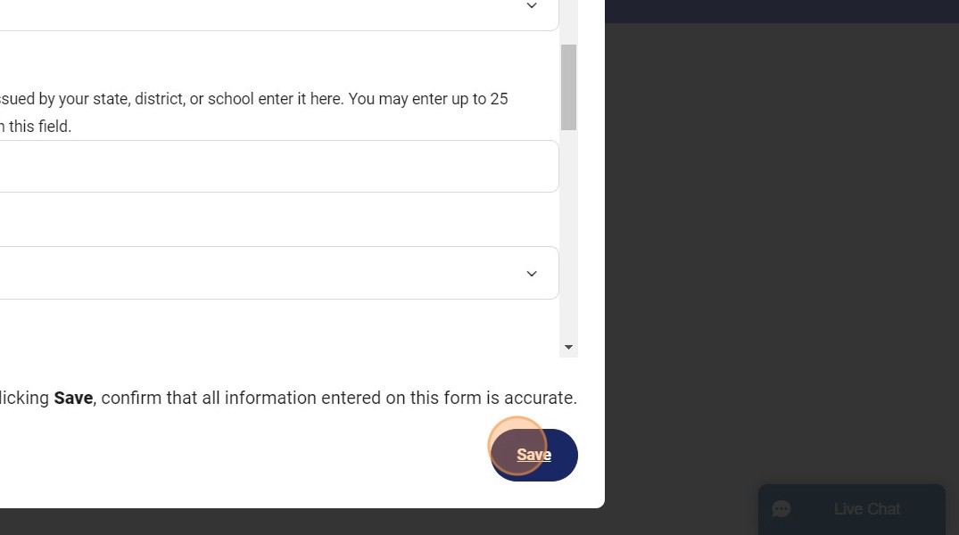

5 Click Save

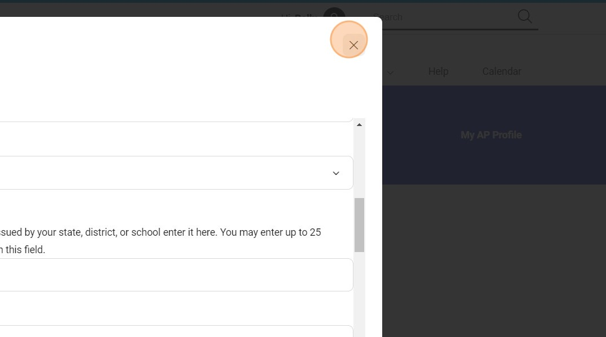

6 Exit and you are done.